**Development of E-commerce Web Portal (QuickCart)**

**Project Scenario**

**1. Project Proposal**

This project aims to develop a user-friendly E-commerce web portal that allows customers to browse, select, and purchase products online. The portal will feature functionalities such as product listing, detailed product views, a shopping cart, a streamlined checkout process, user account management, social media sharing, rating and comments

**2. Functional Specifications**

**Product Listing Page (Home Page):**

* Displays a list of available products.
* Includes features for searching, filtering products

**Product Detail Page:**

* Provides a detailed view of a selected product, including:
* Product name, description, price, images, and user reviews.
* Options to add the product to the shopping cart.
* Social Media Sharing Feature:
* Integrated into the product detail page.
* Provides easy sharing options for Facebook, WhatsApp, Twitter(X)
* Contains a section for user comments and reviews:
* Allows users to submit new comments and ratings.
* Displays a list of user comments, each with options to rating as 1 star to 5 stars.

**Shopping Cart Page:**

* Lists all products that the user has added to the cart.
* Allows users to:
* Update the quantity of each product.
* Remove items from the cart.
* View the total price of the items in the cart.
* Provides a button to proceed to checkout.

**Order Confirmation Page:**

* Displays confirmation details after a successful checkout process, including order number and an order summary with all items, quantities, and the total amount.

**Login/Register Page:**

* Allows users to:
* Log in to their existing account.
* Register for a new account.
* includes fields for username, password, email, and phone number.

**User Profile Page:**

* Displays user account details and order history.
* Allows users to update their profile information and updating their password.

**Team Contributions and Roles**

Each team member had distinct responsibilities and completed specific features in the development of the e-commerce web portal

**Muhammad Azizi Akhmad (G2404748C)**

* + **Role**: Developer and QA
  + **Completed Features**:
    - Implemented the **Login and Registration** functionality.
    - Managed the **User Profile** page, allowing users to update their personal information and password.
    - Conducted thorough testing of each system component to ensure the application functions smoothly.

**Liu Jingtai (G2401699A)**

* + **Role**: Developer and Project Coordinator
  + **Completed Features**:
    - Developed the **Product Detail Page** with features such as **product ratings**, **comments**, and **social media sharing**.
    - Built the **Checkout Process** and **View Order History** pages.
    - Coordinated within the team to ensure timely project delivery and appropriate distribution of development tasks.

**Muhammad Zahin Bin Ramlan (G2405662G)**

* + **Role**: Database Administrator
  + **Completed Features**:
    - Designed and set up the **database schema** and relationships.
    - Integrated the database with the front-end components to enable seamless data retrieval and storage.

**I Muthukumar (G2405943C)**

* + **Role**: Developer
  + **Completed Features**:
    - Developed the **Product Listing Page**, which allows users to search and filter products.
    - Implemented the **Shopping Cart** functionality, including features for updating product quantities, removing items, and calculating the total cost.

**Database Design (ER Diagram)**

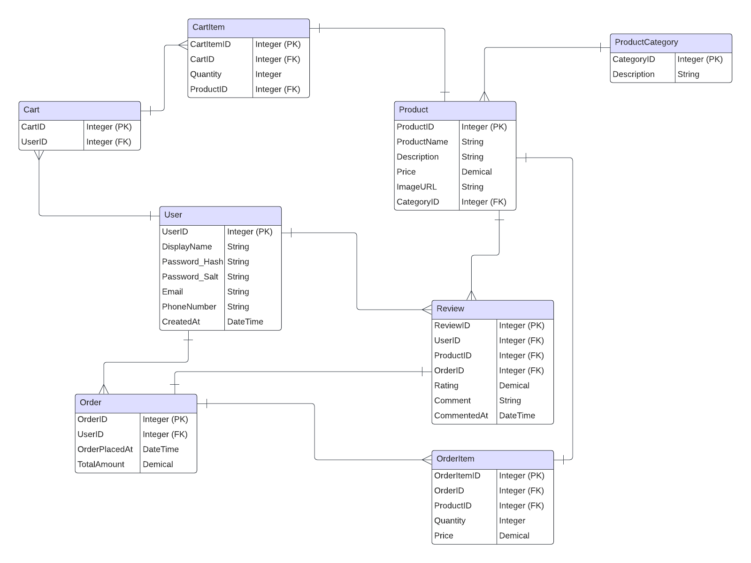

**Project Specifications and Setup Guide**

**Java Version**: Java SE 22

**Server Version**: Apache Tomcat 10.1

**External Referenced Libraries:**

* jackson-databind-2.15.0.jar
* mysql-connector-java-8.0.26.jar
* jackson-core-2.15.0.jar
* jackson-annotations-2.15.0.jar
* jackson-datatype-jsr310-2.15.0.jar

**GitHub Repository URL** - <https://github.com/Steven-Liu-0914/QuickCart>

**Database**

**Endpoint:** quickcart.cqojz0ygx2o6.us-east-1.rds.amazonaws.com

**Master Username:** admin

**Master Password:** 67tXQGVmYOEpiDBX1NSG

**Database Back-Up Copy Script:** [QuickCart-Dump20241022.sql](https://github.com/Steven-Liu-0914/QuickCart/blob/main/QuickCart-Dump20241022.sql)

**Project Setup Guide**

1. **Download and Install Required Tools**:

* **Java Development Kit (JDK) SE 22**: Ensure you have JDK 22 installed.
* **Apache Tomcat 10.1**: Download and set up Tomcat as your server.

1. **Get the Project Source**:

* Clone the project repository from GitHub or Get from the attached Zip Source File, move into your local workspace and load the project using Eclipse.

1. **Configure the Database**

The Configuration of Database Connection String is at **src\main\resources\config.properties**

1. **Build and Deploy**

Open the project in Eclipse, ensuring that the necessary external libraries are added to the build path (should auto-included).

Right-click on the project, select Run As > Run on Server, and choose Tomcat 10.1.

1. **Access the Application**

Open your browser and go to http://localhost:8080/QuickCart to access the e-commerce portal.